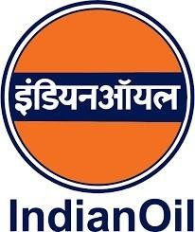

GUWAHATI REFINERY
Noonmati,Guwahati, Assam (781020)

WINTER INTERNSHIP PROJECT REPORT ON

“AUTOMATED PPE DETECTION SYSTEM”

SUBMITTED BY:

- Biswajit Gogoi (The Assam Kaziranga University)
- Sharat Chandra Chetia (The Assam Kaziranga University)
- Bhargab Protim Borah (The Assam Kaziranga University)

CERTIFICATE

This is to certify that the Internship Report on “AUTOMATED PPE DETECTION SYSTEM” submitted by Biswajit Gogoi, Sharat Chandra Chetia and Bhargab Protim Borah is a bonafide record of work done by them and submitted during the Winter Internship starting from 15th of December 2025 to 15th of January 2026.

Mr. Jon Jonak Phukan
Chief Manager, Information System
Indian Oil Corporation Limited, Guwahati

DECLARATION

The project work entitled “AUTOMATED PPE DETECTION SYSTEM” presented in this report has been submitted to the Guwahati Refinery, (INDIAN OIL CORPORATION LIMITED), Noonmati, Guwahati (781020) in fulfilment for completion of the Winter Internship undergone from 15/12/2025 to 15/01/2026.
This report has not been submitted for any other examination and does not form part of any other course undergone by us.

Sincerely,
Biswajit Gogoi
Sharat Chandra Chetia
Bhargab Protim Borah

ACKNOWLEDGEMENT

We are thankful to IOCL, Guwahati Refinery, Noonmati, Guwahati, for providing us an opportunity to undergo the Winter Internship. We perceive this opportunity as a big milestone in our career development. We will strive to use gained skills and knowledge in the best possible way and will continue to work on their improvement, in order to attain desired career objectives.

We articulate our sincere gratitude to our project guide Mr. Jon Jonak Phukan, Chief Manager(IS) Indian Oil Corporation Ltd. who has spent his valuable time and guided us throughout the training process in developing an automated PPE detection system.

We also express our gratitude to Mr. Gaurav Borah, SM (M, L&D), IOCL, Guwahati Refinery, for his guidance and extended support in assigning our guides and also briefing us about IOCL, Guwahati.

ABSTRACT

We developed this automation solution, known as the “Automated PPE Detection System,” to address the need for continuous safety compliance monitoring in the Guwahati Refinery, IOCL. The system focuses on ensuring that workers adhere to safety protocols, particularly the mandatory use of safety helmets and safety vests in all areas inside the refinery, which is critical for reducing workplace accidents and injuries.

The system uses computer vision to analyze real-time video feeds from surveillance determining whether workers are wearing safety helmets and safety vests . It tracks compliance statistics, including the number of workers following safety protocols and instances of non-compliance. We aim to generate detailed reports and alerts, highlighting areas or shifts (time of workday) with higher violation rates, enabling targeted intervention and reinforcement of safety measures.

Supervisors can access dashboards providing comprehensive data on helmet compliance, including violation counts and trends over time. This ensures timely and actionable insights into safety practices, thereby helping Indian Oil to proactively address non-compliance and improve adherence to safety standards.

By automating PPE monitoring, we aim to help enhance the efficiency and accuracy of safety compliance tracking while reducing manual efforts at monitoring. This project aims to significantly contribute to promoting a culture of safety and responsibility at IOCL, ensuring a safer and more productive working environment inside the refinery.

ABOUT INDIAN OIL CORPORATION LTD

(Indian Oil Corporation) was formed in 1964 as the result of merger of Indian Oil Company Ltd. (Estd. 1959) and Indian Refineries Ltd. (Estd. 1958).
Indian Oil Corporation Ltd. is the highest ranked Indian company in the prestigious Fortune ‘Global 500’. It is ranked at 109th position in 2010. It is also the 20th largest petroleum company in the world.

Indian Oil and its subsidiaries today account for 49% petroleum products market share in India. In May, 2018, IOCL became India's most profitable state-owned company for the second consecutive year, with a record profit of ₹21,346 crore in 2017-18.

VISION OF IOCL
A major diversified, transnational, integrated energy company, with national leadership and a strong environmental conscience, playing a national role in oil security & public distribution.

BUSINESS DIVISIONS
There are 7 major Business Divisions in the organization:
- Refineries Division.
- Pipelines Division
- Marketing Division
- R&D Division
- Petrochemicals Division
- Exploration & Production (E&P) Division
- Explosives and Cryogenics Division

REFINERY LOCATIONS
- Barauni Refinery
- Bongaigaon Refinery
- CPCL, Chennai
- CPCL, Narimanam
- Digboi Refinery
- Guwahati Refinery
- Haldia Refinery
- Koyali Refinery
- Mathura Refinery
- Panipat Refinery
- Paradip Refinery

PRODUCTS OFFERED BY IOCL

Indian Oil is not only the largest commercial enterprise in the country, it is the flagship corporate of the Indian Nation. Besides having a dominant market share, Indian Oil is widely recognized as India’s dominant energy brand and customers perceive Indian Oil as a reliable symbol for high quality products and services.

Major Products of IOCL are:
- Indane Gas
- Auto Gas
- Natural Gas
- Diesel/Gas oil
- ATF/Jet Fuel
- SERVO lubricants & greases
- Marine Fuels & Lubricants
- Kerosene

`

PROBLEM STATEMENT

The Information System Department of Guwahati Refinery emphasizes the use of
technology-driven solutions to improve safety and operational efficiency within
the refinery premises. Ensuring that workers consistently wear mandatory Personal
Protective Equipment (PPE) is a critical safety requirement in hazardous industrial
environments such as oil refineries.

Manual monitoring of PPE compliance is time-consuming and prone to human error,
especially when large areas and multiple work zones need to be supervised
simultaneously. Occasional non-compliance by workers, such as not wearing safety
helmets or safety vests, can significantly increase the risk of workplace
accidents and injuries.

To address this issue, there is a need for an automated system capable of
continuously monitoring PPE usage in real time, accurately detecting violations,
and maintaining proper records. The “Automated PPE Detection System” aims to
fulfil this requirement by leveraging computer vision and deep learning
techniques to improve safety compliance within the refinery environment.

OBJECTIVE

The objective of the “Automated PPE Detection System” is to design and implement
an automated solution that monitors PPE compliance among workers using real-time
video feeds. The system utilizes computer vision techniques to detect the presence
or absence of essential PPE such as safety helmets and safety vests.

The system aims to identify non-compliance instances, generate visual alerts,
capture violation snapshots, and maintain structured logs for safety analysis and
reporting. By providing supervisors with real-time insights and downloadable
reports, the system supports effective enforcement of safety protocols.

Through automation, the project seeks to reduce manual supervision efforts,
improve monitoring accuracy, and promote a safer and more disciplined working
environment within industrial workplaces.

TABLE OF CONTENTS

Sl. No. Contents Page No.
- Certificate ii
- Declaration iii
- Acknowledgement iv
- Abstract v
- Overview of IOCL (About, Vision, Business, Division-----------------vi
- Products offered by IOCL ---------------------------------------------------------vii
- Problem Statement viii
- Objective --------------- viii
- Table of Contents ix
- List of Figures x
- Introduction 1-3
- Project Roadmap 4
- Literature Review 5-6
- Software Requirement Specification 7-11
- Methodology 12-18
- Analysis 19
- Conclusion 20
- Futuristic Scope 21-22
- References 23

LIST OF FIGURES

FIGURES | Page No.
Figure 1: Dataset structure used for PPE detection training | 12
Figure 2: Training of YOLOv8 model using Google, CMD | 12
Figure 3: Trained model weights file (best.pt) | 13
Figure 4: Project file organization in Django framework | 13
Figure 5: Real-time PPE detection output on web interface | 14
Figure 6: Violation log entry stored in CSV format | 14
Figure 7: Captured snapshot of PPE violation | 14

CHAPTER 1: INTRODUCTION

About YOLO and YOLOv8

You Only Look Once (YOLO) is a state-of-the-art object detection algorithm that performs object detection in a single forward pass of a neural network, making it highly efficient and suitable for real-time applications. YOLO is widely used in areas such as surveillance, autonomous systems, and industrial safety monitoring due to its ability to detect multiple objects simultaneously with high accuracy.

YOLOv8 is the latest version of the YOLO family and offers significant improvements in detection accuracy, speed, and model architecture. It supports custom training and multi-class detection, making it highly suitable for domain-specific applications such as Personal Protective Equipment (PPE) detection in industrial environments.

1.2 Advantages OF YOLO

1. Real-Time Performance:
YOLO processes video frames at high speed, making it ideal for real-time
monitoring systems.

2. High Accuracy:
YOLOv8 provides an effective balance between detection accuracy and inference
speed.

3. Multi-Object Detection:
It can detect multiple objects, including persons and PPE items, in a single
frame.

4. Lightweight Architecture:
The optimized architecture allows deployment on systems with limited hardware
resources.

5. Customizability:
YOLOv8 can be trained on custom datasets to meet specific application
requirements.

Disadvantages of YOLO

1. Training Resource Requirements:
Training the model requires high-quality datasets and significant computational resources.

2. Sensitivity to Environmental Conditions: Detection performance may degrade in low-light conditions or highly cluttered scenes.

3. Limited Context Understanding: YOLO focuses on object detection and does not inherently understand contextual relationships between objects.

4.Integration Challenges:
Deployment and integration with existing systems may require technical expertise.

Use of YOLO in PPE Detection System

The Automated PPE Detection System leverages YOLOv8 to ensure continuous safety compliance monitoring within industrial environments. By integrating the YOLOv8 model with real-time video feeds, the system detects workers and verifies the presence of mandatory PPE such as safety helmets and safety vests.

Bounding boxes are displayed around detected individuals, visually indicating compliance and non-compliance. Confirmed PPE violations are logged automatically, and snapshots are captured for further review and analysis.

Technologies Required

The major technologies used in this project include:

    - Python – Core programming language
    - Django – Web framework for backend development
    - YOLOv8 – Object detection model
    - OpenCV – Video processing and frame handling
    - HTML, CSS, JavaScript – Frontend development
    - SQLite – Database for application data storage

The “Automated PPE Detection System” is developed using a combination of modern software technologies that enable real-time video processing, accurate object detection, and efficient web-based monitoring.

Python is used as the primary programming language due to its simplicity, extensive library support, and strong community backing for machine learning and computer vision applications. It serves as the core language for implementing the detection logic, data processing, and backend services.

Django is used as the web framework to build the backend of the system. It provides features such as user authentication, URL routing, session management, and secure handling of requests. Django enables the integration of the PPE detection module with a web-based dashboard for real-time monitoring, violation alerts, and report generation.

YOLOv8, a deep learning-based object detection model, is used for detecting persons and PPE items such as safety helmets and safety vests. A custom-trained YOLOv8 weights file is used to improve detection accuracy in industrial environments. The model processes video frames in real time and identifies PPE compliance with high efficiency.

OpenCV is used for video capture and frame-by-frame processing of live camera feeds. It is responsible for reading video streams, resizing frames, drawing bounding boxes, and displaying detection results. OpenCV also assists in saving violation snapshots for further analysis.

HTML, CSS, and JavaScript are used to design the frontend interface of the system. These technologies provide a user-friendly web dashboard that allows supervisors to start and stop detection, view live video feeds, receive violation alerts, and download reports.

SQLite is used as the database to store application-related data, while CSV files are used to log PPE violation records. These logs include timestamps, violation details, and snapshot paths, enabling easy access for auditing and reporting purposes.

z
  - PROJECT ROADMAP

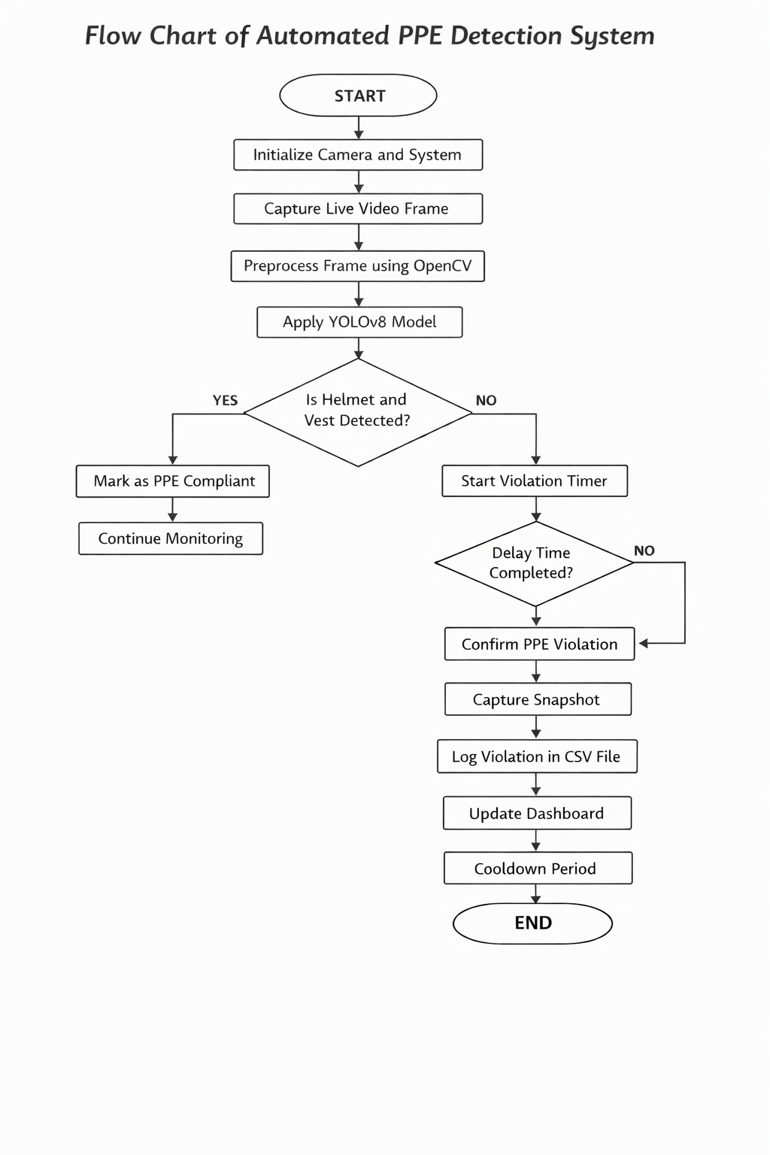

CHAPTER 2:LITERATURE REVIEW

NEED ANALYSIS:

- Industrial environments such as oil refineries involve hazardous operations where strict safety protocols must be followed to prevent accidents and injuries.

- Personal Protective Equipment (PPE), including safety helmets and safety vests, is mandatory for workers operating in high-risk zones.

- Manual monitoring of PPE compliance requires continuous human supervision, which is labour-intensive and prone to inconsistencies due to fatigue or oversight.

- Supervising large industrial premises with multiple work zones using manual methods is often impractical and inefficient.

- Delayed identification of PPE violations can result in serious safety hazards and increase the likelihood of workplace accidents.

- Automated PPE detection systems provide continuous monitoring without human intervention and ensure consistent enforcement of safety regulations.

- Real-time detection of non-compliance enables immediate corrective action by safety personnel.

- Systematic digital logging of violations supports safety audits, compliance verification, and long-term safety planning.

- The integration of automation improves operational efficiency while enhancing overall workplace safety and accountability.

LITERATURE SURVEY

Author Name,  Institute, Year | Title of the Paper | Inference | Research Gap | Relevance to the work
Prof. R. Senthil Kumar,  Dr. P. Mahalakshmi,  Government Polytechnic College, Coimbatore, Tamil Nadu  Year: 2022 | Real-Time Personal Protective Equipment Detection using Deep Learning | 1. The research presents a deep learning-based approach for detecting personal  protective equipment such as helmets and safety vests in industrial environments.  2. The proposed system demonstrates the feasibility of real-time PPE detection  using convolutional neural networks for improving workplace safety compliance. | 1. The study lacks integration with a web-based monitoring platform for real-time  visualization and supervisory control.  2. There is no provision for automated violation logging, snapshot capture, or  generation of downloadable compliance reports. | 1. Our project extends this research by integrating PPE detection with a Django-  based web dashboard for live monitoring and user interaction.  2. The limitation of missing reporting and logging features is addressed in our  system through automated snapshot capture, CSV logging, and violation reporting,  making the solution more suitable for practical industrial deployment.
Dr. Ankit Sharma,  Dr. Neha Verma,  Department of Computer Science,  National Institute of Technology (NIT), Silchar, Assam  Year: 2022 | Deep Learning-Based Personal Protective Equipment Detection for Industrial Safety | 1. The study presents a deep learning-based approach for detecting personal  protective equipment such as helmets and safety vests in industrial  environments using convolutional neural networks.  2. The research highlights the effectiveness of automated PPE detection systems  in improving safety compliance and reducing accident risks in hazardous  workplaces. | 1. The proposed system does not include real-time deployment through a web-based  interface for continuous monitoring.  2. Automated violation logging, evidence capture, and report generation are not  addressed in the study, limiting its practical applicability. | 1. Our project aligns with this research by implementing deep learning-based PPE  detection while extending it to real-time monitoring using a Django web  application.  2. The limitations identified in the study are addressed in our system through  automated snapshot capture, CSV-based logging, and downloadable violation  reports, making the solution suitable for real-world industrial deployment.

  - SOFTWARE REQUIREMENT SPECIFICATION (SRS)

This SRS document describes the functional and non-functional requirements, system features, and design constraints of the “Automated PPE Detection System”.

Overall Description

The product is a computer vision–based system designed to detect Personal Protective Equipment (PPE) usage in real time using live video feeds. The system is implemented using deep learning and web technologies to ensure continuous monitoring of safety compliance in industrial environments such as refineries.

The system captures live video streams, processes them using a YOLOv8-based object detection model, and identifies whether workers are wearing mandatory PPE such as safety helmets and safety vests. The system is intended to assist safety officers by providing real-time alerts, violation records, and compliance reports.

Product Functions

• Detect and classify persons wearing PPE and without PPE in real time from live video feeds.
• Identify safety helmets and safety vests using a deep learning detection model.
• Generate alerts for PPE non-compliance.
• Capture snapshots of confirmed PPE violations.
• Log violation details with date and time information.
• Display live monitoring and compliance status on a web-based dashboard.
• Generate downloadable reports for analysis and record keeping.

User Classes and Characteristics

• Safety Officers: Monitor live video feeds, receive alerts for PPE violations, and review compliance reports.
• Refinery Workers: Are monitored passively by the system while performing daily operations.
• Administrators: Manage user access, system configuration, and review logged data and reports.

Operating Environment

• The system operates on a computer system connected to a camera (webcam or CCTV).
• The backend is implemented using Python and Django.
• The detection model runs using YOLOv8 and OpenCV.
• The system can operate on standard desktop hardware.
• The web application is accessed through a browser interface.

Design and Implementation Constraints

• Real-time video processing requires sufficient computational resources.
• Detection accuracy depends on camera quality and lighting conditions.
• Environmental factors such as occlusion may affect detection performance.
• System performance may vary based on hardware specifications.

Assumptions and Dependencies

• Cameras are positioned to clearly capture workers and PPE items.
• PPE items are visually distinguishable in the video feed.
• Authorized users have access to the web interface.
• Continuous power supply and system availability are ensured.

SYSTEM FEATURES

- Real-Time Detection

Description and Priority:
The system must detect PPE compliance in real time using live video feeds. This is a high-priority feature to ensure immediate identification of non-compliance.

Functional Requirements:
• The system shall process live video streams frame by frame.
• The system shall detect persons present in the video frame.
• The system shall identify whether a person is wearing a helmet and safety vest.
• The system shall label individuals as “PPE Compliant” or “PPE Violation” in real time.

- Violation Alerts

Description and Priority:
The system must generate alerts for detected violations to enable timely corrective action.

Functional Requirements:
• The system shall trigger a violation alert when PPE is not detected.
• The system shall confirm violations after a predefined delay.
• The alert shall include date and time information.

- Snapshot Capturing

Description and Priority:
Snapshots of PPE violations should be captured and saved for compliance review.

Functional Requirements:
• The system shall automatically capture snapshots of confirmed PPE violations.
• Captured images shall include bounding boxes around detected individuals.
• Snapshots shall be stored with timestamp information.

- Data Logging

Description and Priority:
All detection events must be logged for record keeping and analysis.

Functional Requirements:
• The system shall log PPE violation details including date, time, and image path.
• Logs shall be stored in CSV format for easy access.

- Dashboard and Reporting

Description and Priority:
The system must provide a user-friendly dashboard to visualize monitoring results
and generate reports.

Functional Requirements:
• The system shall display real-time detection results on a dashboard.
• The system shall allow users to download violation reports.
• Reports shall assist supervisors in analyzing safety compliance trends.

NON-FUNCTIONAL REQUIREMENTS

- Performance:
The system shall process live video streams in real time with minimal delay to ensure timely detection of PPE compliance. The detection accuracy shall remain high under normal operating conditions, and alerts shall be generated promptly after confirmed violations.

- Security:
The system shall ensure secure access through user authentication mechanisms. Detection logs, violation images, and reports shall be securely stored to prevent unauthorized access.

- Usability:
The system shall provide a user-friendly and intuitive dashboard interface that allows supervisors to easily monitor live video feeds, view violation alerts, and download reports without requiring technical expertise.

- Reliability:
The system shall operate continuously with minimal downtime. It shall be able to recover from minor interruptions such as temporary camera disconnections without loss of violation data.

- Scalability:
The system shall support future expansion, including the addition of multiple cameras and detection of additional PPE items without major architectural changes.

- Maintainability:
The system shall be easy to maintain and update. Model updates, system enhancements, and bug fixes shall be carried out without significantly disrupting system operation.

- Environmental Adaptability:
The system shall maintain consistent performance under varying environmental conditions such as changes in lighting, partial occlusions, and background complexity.

CHAPTER 3: METHODOLOGY

Module 1: Training the YOLO Model

Dataset: https://www.kaggle.com/datasets/mugheesahmad/sh17-dataset-for-ppe-detection

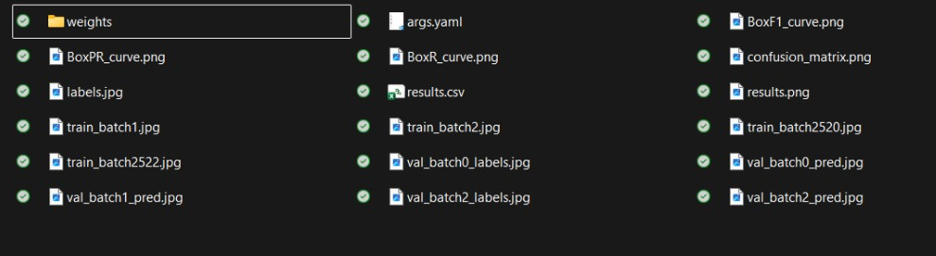

Figure 1: Files in the dataset for YOLOv8 training

Figure 2: Training the model

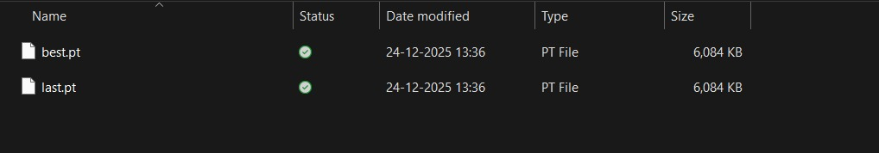

Figure 3: best.pt file obtained after training

Module 2: Using the Weights from Training to Detect

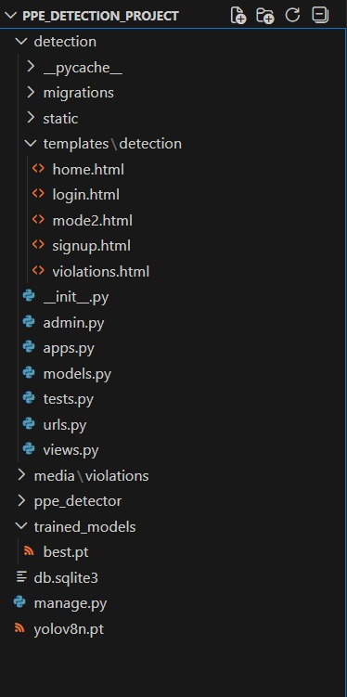

Figure 4: File organization in VS code

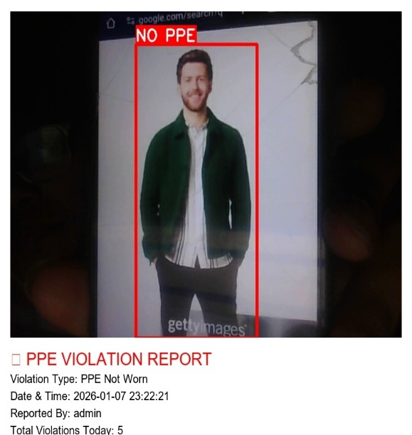
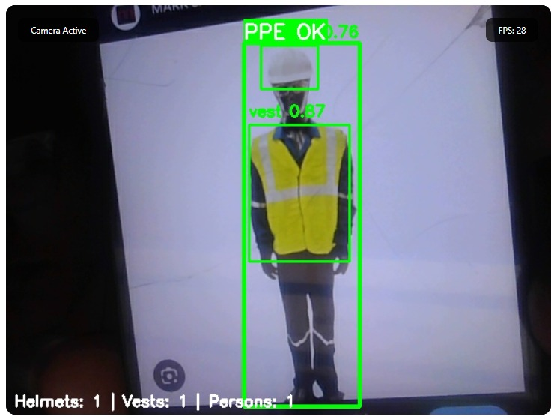

Figure 5: Real time detection using YOLOv8

Module 3: Logging Entries for Violations

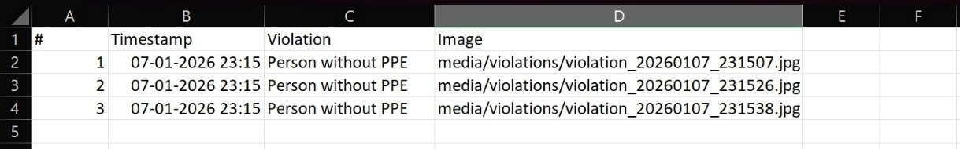

Figure 6: Log entry in CSV file

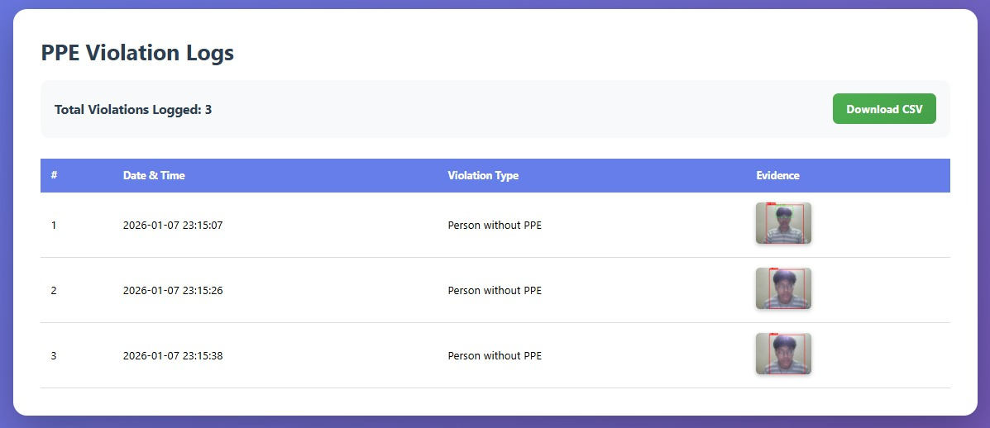

Figure 7: Snapshot entry

Once a PPE violation is detected in a video frame, an entry is created in a CSV log file. Each log entry contains the timestamp of the detection, the detected class, the confidence score of the detection, and the bounding box coordinates of the object.

In addition, the log records the count of “with helmet”, “without helmet”, “with vest”, and “without vest” detections, along with the file path of the saved snapshot corresponding to the violation incident.

All violation snapshots are stored in a separate directory named “snapshot”. Each snapshot is saved using a unique filename generated based on the timestamp at which the image is captured, ensuring proper identification and easy retrieval of violation records.

Code

- Model Loading Code:

def load_model():
global model
if model is None:
model = YOLO("trained_models/best.pt")

- Model Inference and Object Detection

results = model(frame, conf=0.4)

for result in results:
for box in result.boxes:
cls = int(box.cls[0])
name = model.names[cls].lower()

if name in helmet_classes:
detected_helmets.append(box)
elif name in vest_classes:
detected_vests.append(box)
elif name == "person":
detected_persons.append(box)

- PPE Compliance Decision Logic

if has_helmet and has_vest:
label = "PPE OK"
elif has_helmet and not has_vest:
label = "NO VEST"
elif has_vest and not has_helmet:
label = "NO HELMET"
else:
label = "NO PPE"

System Workflow

- Video Input:

The system reads a live video feed frame by frame using OpenCV’s video capture mechanism. The video stream serves as the primary input for PPE detection.

Helmet Detection:

YOLOv8 processes each video frame to detect:

“Helmet” (indicating individuals wearing safety helmets)

“Vest” (indicating individuals wearing safety vests)

“Person” (used to associate PPE with individuals)

The detection model evaluates PPE compliance for each detected person.

Bounding Boxes & Annotations:

For each detected individual:
- Bounding boxes are drawn around persons and detected PPE items.
- Labels indicating “PPE OK”, “NO HELMET”, “NO VEST”, or “NO PPE” are displayed.
- Confidence scores are shown alongside the detection labels.

Violation Detection and Confirmation:

  - If a person is detected without the required PPE, a violation timer is started.
  - The violation is confirmed only if the non-compliance persists beyond a predefined delay period.
  - This delay-based confirmation helps reduce false positives.

- Snapshot and Logging Conditions:

• Once a violation is confirmed, a snapshot of the video frame is captured.
• The captured image is saved with a unique timestamp-based filename.
• Violation details such as date, time, violation type, and image path are logged into a CSV file.
- Snapshot Storage:

• All violation snapshots are stored in a dedicated directory.
• Each snapshot is saved using a unique timestamp-based naming convention for easy retrieval and record management.

- Real-Time Display:

• The processed video frames with bounding boxes and annotations are displayed on a web-based dashboard.
• PPE compliance status and violation alerts are updated in real time for monitoring purposes.

- Exit and Resource Management:

• The system continues monitoring until manually terminated by the user.
• On termination, the system safely releases video resources and finalizes all
logging operations.

CHAPTER 4: ANALYSIS

User Side

• Real-Time Monitoring: Users, such as safety supervisors, can view live video feeds with bounding boxes
indicating PPE compliance status such as “Helmet Detected”, “Vest Detected”, or “PPE Violation” for each detected individual.

• Violation Notifications: Supervisors receive instant alerts for PPE non-compliance along with captured snapshots and timestamps, enabling quick corrective action.

• Dashboard Interface: A user-friendly dashboard allows supervisors to review compliance metrics, monitor live detection results, and generate violation reports for analysis.

• Ease of Use: The system requires minimal training, allowing users to operate it efficiently through an intuitive and well-organized interface.

Server Side

• Object Detection: The YOLOv8 model processes live video streams and accurately detects persons, safety helmets, and safety vests in real time.

• Snapshot and Logging: PPE non-compliance events are automatically logged into a CSV file, with snapshots saved for evidence and analysis. Each log entry includes timestamp, violation type, and confidence score.

• Data Management: The system organizes violation logs and snapshots systematically, ensuring easy retrieval, secure storage, and optimized data management.

CHAPTER 5: CONCLUSION

The “AUTOMATED PPE DETECTION SYSTEM” project is a strategic initiative designed to enhance workplace safety by leveraging advanced computer vision and deep learning technologies. The system addresses the limitations of manual safety compliance monitoring by providing an automated, accurate, and efficient solution for PPE detection inside the Guwahati Refinery.

By automating the detection, confirmation, and logging of PPE compliance, the system significantly reduces the workload on safety officers and minimizes the risk of human oversight. Real-time monitoring, instant violation alerts, and systematic record keeping ensure that supervisors are promptly informed of non-compliance incidents.

The implementation of this system aligns with the commitment of IOCL to adopt modern technologies for operational excellence and safety enhancement. The project supports improved compliance tracking, proactive safety management, and the development of a strong safety culture.

In conclusion, the “AUTOMATED PPE DETECTION SYSTEM” offers a reliable and scalable solution for real-time PPE monitoring, contributing to safer and more efficient industrial operations.

CHAPTER 6: FUTURISTIC SCOPE

The current implementation of the “AUTOMATED PPE DETECTION SYSTEM” provides a reliable solution for monitoring safety compliance in industrial environments. However, there are several areas where future enhancements and integrations can further expand its capabilities and improve overall effectiveness. Some potential future developments are discussed below.

Detection of Additional PPE Items:

• Purpose: To extend safety monitoring beyond helmets and safety vests by including other protective equipment.
• Implementation: Train the detection model to identify additional PPE such as gloves, goggles,
face shields, and protective footwear using an expanded dataset.

Monitoring by Area and Shift:

• Purpose: To analyze safety compliance based on specific locations and working shifts within the industrial premises.
• Implementation: Tag detection data with area identifiers and shift timings to identify high-risk zones or periods with frequent PPE violations.

Integration with Centralized Databases:

• Purpose: To enable centralized storage and long-term analysis of compliance logs and violation records.
• Implementation: Integrate relational or cloud-based databases to store detection logs, snapshots, and compliance data for easy retrieval and reporting.

Multi-Camera Support:

• Purpose: To monitor larger industrial areas simultaneously and improve coverage.
• Implementation: Extend the system architecture to support multiple camera feeds and aggregate detection results on a centralized dashboard.

Advanced Analytics and Trend Analysis:

• Purpose: To gain deeper insights into safety compliance trends and worker behavior over time.
• Implementation: Apply data analytics techniques on historical violation data to generate trend
reports and identify recurring safety issues.

Predictive Safety Analysis:

• Purpose: To forecast potential safety risks and prevent accidents before they occur.

• Implementation: Use machine learning models to analyze past violation patterns and generate predictive alerts for proactive safety management.

Cloud and IoT Integration:

• Purpose: To enable real-time monitoring and alerting across multiple locations.
• Implementation: Integrate cloud platforms and IoT-enabled cameras to allow remote access, centralized control, and scalable deployment.

Privacy and Data Protection Enhancements:

• Purpose: To address privacy concerns associated with continuous video monitoring.
• Implementation: Implement data encryption, access control, and anonymization techniques to ensure secure handling of video and log data.

REFERENCES

1. Ultralytics, “YOLOv8 Documentation.” Retrieved from https://docs.ultralytics.com/

2. Redmon, J., Divvala, S., Girshick, R., & Farhadi, A. (2015). You Only Look Once: Unified, Real-Time Object Detection. arXiv preprint arXiv:1506.02640.

3. Django Software Foundation, “Django Documentation.” Retrieved from https://docs.djangoproject.com/

4. OpenCV Team, “OpenCV Documentation.” Retrieved from https://docs.opencv.org/

5. International Labor Organization, “Occupational Safety and Health.” Retrieved from https://www.ilo.org/

6. Patel, K., Patel, V., Prajapati, V., Chauhan, D., Haji, A., & Degadwala, S. (2023). https://www.researchgate.net/publication/374467271_Safety_Helmet_Detection_Using_YOLO_V8

7. Lin, B. (2024). Safety Helmet Detection Based on Improved YOLOv8. ResearchGate.
https://www.researchgate.net/publication/378347736_Safety_Helmet_Detection_Based_on_Improved_YOLOv8

8. Ultralytics, “YOLOv8 Explained.” YouTube. https://www.youtube.com/watch?v=Z-65nqxUdl4

9. Ultralytics, “YOLOv8 Custom Dataset Training.” YouTube. https://www.youtube.com/watch?v=GmX3KfV8GJQ

10. S17 Shubham, “Industrial PPE Detection Dataset (SH17).” Kaggle. https://www.kaggle.com/datasets/s17shubham/industrial-ppe-detection

11. YOLO Tutorial (2020, December 20). YouTube. https://www.youtube.com/watch?v=ag3DLKs12vk&t=296s

12. Bike Helmet Detection (2024, August 17). YouTube https://www.youtube.com/watch?v=p594ukHmRI

13. Django and OpenCV Video Streaming Tutorial. YouTube. https://www.youtube.com/watch?v=8C6iV4sE3nI

14. MDPI Sensors Journal, “Vision-Based PPE Detection Systems.” https://www.mdpi.com/

